Defying climate and human perturbations? The unusual case of the coral Orbicella faveolata in Varadero Reef, Colombian Caribbean
Abstract
Introduction
Coral reefs develop under a set of environmental and physical-chemical water conditions that do not limit their growth and distribution at the local, regional or global level (Kleypas et al. 1999; Guan et al. 2015). This knowledge has been important to develop strategies for its conservation and management (McClanahan et al. 2002; Mora and Sale 2011). However, coral reefs continue to be threatened by climate change, acidification, diseases and pollution (Hughes et al. 2003; Bruno et al. 2007; Hoegh-Guldberg et al. 2007; Knowlton and Jackson 2008). These climate and anthropogenic effects threaten the persistence of an invaluable ecosystem that provides numerous benefits to humanity, such as food, medicine, coastal protection, tourism, etc. (Bryant et al. 1998). The disappearance of these ecosystems could mean enormous economic losses, mainly in countries that enjoy or depend on their benefits (Cesar et al. 2003; Hoegh-Guldberg 2011).
Despite of an adverse present for corals, there is evidence that suggest reefs will not disappear entirely, instead they will evolve in response to the rapid environmental changes they are facing (Hughes et al. 2003). Some reefs have already shown their capacity to cope with warming and acidification through sources of variation, like phenotypic plasticity, which might enhance their persistence and evolution under unusual conditions (Pandolfi et al. 2011). Evaluating the resistance and recovery of coral reefs over disturbances and local environmental conditions is critical for the development of effective conservation actions (McClanahan et al. 2012). However, the current state of knowledge on coral reef resilience makes it difficult to select meaningful conservation criteria useful for managers and policy-makers.
In Cartagena Bay, Colombia, exists a paradoxical coral reef, the Varadero coral reef. This reef is shown as healthy, high coral diversity, and large colonies of the coral Orbicella faveolata (López-Victoria et al. 2015; Pizarro et al. 2017), an important species that contributes to the reef's accretion in the Caribbean. All of these characteristics occurring under the contamination from the Canal del Dique water discharges and the influence of the Magdalena River, one of the most contaminated rivers in Colombia and the river which has the highest sediment transport per unit area (sediment yield) in Latin America (Restrepo and Kjerfve 2000). Today, the Canal del Dique is considered an arm of the Magdalena River, which has been first built by the Spaniards in the 16th century and has suffered several dredges and enlargements during the last century (Lemaitre 1982; Aguilera 2006). This channel carries about 5.9 million t/year of fine sediments, nutrients and pollutants that are washed from land into the watershed. These discharges turned Varadero waters into turbid and eutrophied, with heavy metals, hydrocarbons and organochlorines (Mogollón 2013).
The large size of the O. faveolata colonies are unusual under conditions as adverse as those in Varadero. Large colonies could hold the key to understanding the impact of climate and man-made perturbations in the history of Cartagena. In addition, they can provide valuable information about the adaptation these corals have had, and why they seem to be in better conditions than other Caribbean reefs. In the present study, we studied skeletons of the coral O. faveolata in order to understand and track historical perturbations in Cartagena Bay and their effects on coral growth.

Material and methods
Study area
The coral reef of Varadero is found at 5.5 km off the mouth of Canal del Dique, within Cartagena Bay, Colombian Caribbean (Fig. 1a-c). This is a well-developed coral reef influenced by the turbid and polluted waters from the Canal del Dique (Fig. 1d, Fig. 2), which is considered as an arm from the Magdalena river (Fig.1b). The area present bimodal climate patterns and climatology during 1950-2015 indicates that the driest and coolest months are from December to April, and the rainiest and hottest months are from September to November (Fig. 3). This seasonality influences the patterns of water flow, water level and sediment load from the Canal del Dique throughout the year (Fig. 3). Therefore, the extension of the sediment plume produced by the Canal del Dique is highly variable, and most of the time can completely cover the reef (Fig. 2). The reef covers an area of about 1 km² and presents up to 80% of live coral cover, dominated by massive colonies of the coral Orbicella faveolata >3 m in diameter (López-Victoria et al. 2015; Pizarro et al. 2017; Fig. 1d). Different coral species can be seen growing in apparent good conditions and competing each other for space (Fig. 1e).
Sampling and growth analysis
Coral cores of 6 cm in diameter were collected with a pneumatic drill along the growth axis from 4 massive colonies of Orbicella faveolata at 3-4 m depth. The affected live coral tissue (25-30 cm²) was covered with a polystyrene ball and epoxy putty to avoid the intrusion of bioeroder organisms. The cores were rinsed with fresh-water several times to remove sediment particles and then oven-dried for 24-48h at 50-60°C.
Three coral cores (VAR2, VAR3, VAR4) along with an aragonite step-wedge standard were imaged using a General Electric LightSpeed VCT 64 CT-scan (Lizcano-Sandoval et al. 2019). The aragonite standard was obtained from the shell of the giant clam Tridacna maxima and was used to estimate coral density (Lizcano-Sandoval et al. 2019). All images were analyzed using the software RadiAnt DICOM Viewer 4.0. The multi-planar reconstruction of coral cores allowed to select the best planes for observing the density banding pattern. One image from sagittal and coronal planes each per core was used. One transect per image along the coral growth axis was made to extract optical density values in Hounsfield units (HU). The HU values were then converted to skeletal density in g cm⁻³ by using a calibration curve (Lizcano-Sandoval et al. 2019).
The fourth coral core (VAR1) was cut into slabs of 0.6 mm thick, radiographed using a conventional X-ray machine and analyzed following Carricart-Ganivet & Barnes (2007). As this is a method that estimates coral skeleton density based not only on the aragonite standard but on pixel intensity as well, it is important to correct the radiation effects over the radiograph. This is not required for CT images. The radiation effects were corrected following Duprey (2012).
The annual skeletal density pattern (See Fig. 4 as an example) for orbicellid corals is the result of a high density band formed during the warm season (last months of the year) and a low density band formed during the cold season (first months of the year) (Carricart-Ganivet et al. 2000; Carricart-Ganivet 2004). According to the climatology for Cartagena Bay (Fig. 3), the highest and lowest density peaks were matched for October and February, respectively. For both CT-scan and X-ray images, coral years were then counted retrospectively. Finally, the skeletal density (g cm⁻³), linear extension (cm yr⁻¹) and calcification rates (g cm⁻² yr⁻¹) were estimated by year, in both growth analysis methods. Calcification is calculated as the product of skeletal and linear extension values. Growth parameters for every coral core were calculated and standardized anomalies (STDA) built. STDA is calculated from each value (annual) minus the mean (over the respective base period), divided by the standard deviation.
Coral luminescence
After CT-scanning, coral cores were cut into slabs and treated with reagent grade NaOCl 13% for 24 h (Nagtegaal et al. 2012), rinsed several times with distilled water and then oven-dried for 24 h at 60°C. The annual luminescence patterns on coral cores (Fig. 4) were visualized and photographed with a Canon XXX under UV-A light (Opalux blacklight bulb T8 20W) in a black box. The red, green and blue (RGB) values were extracted from tracks (5 mm or 62 pixels width) made along the coral growth axis for every photograph using the software ImageJ 1.51. Then, the green/blue (G/B) spectral ratio was used as a measurement for luminescence intensity. Spectral G/B ratios reflect the influence of humic acid/aragonite ratios within the coral skeleton (Grove et al. 2010), in which the higher G/B intensity the higher freshwater and sediments discharge. For instance, the highest and lowest annual luminescence peaks were matched for the months of highest (March) and lowest (December) water flow and sediment load records, respectively (Fig. 3). Estimations of luminescence intensities through this method using photographs are reliable as demonstrated by Tanzil et al. (2016).
Hydrological and environmental data
Monthly data of water flow (1981‒2015), sediment load (1984‒2015) and water level (1984‒2015) from the Canal del Dique at Santa Helena station (id 29037450) (Fig. 1b) were obtained from the Instituto de Hidrologia and Metereologia y Estudios Ambientales (IDEAM). Monthly precipitation data (1954‒2013) was obtained from the IDEAM’s Escuela Naval station (id 14015030) (Fig. 1b).
Monthly sea surface temperature (SST; 1951‒2015) was obtained from the 1° x 1° gridded HadISST dataset (Rayner et al. 2003) centered on 9°30’‒10°30’ N and 75°30’‒76°30’ W. The Southern Oscillation Index (SOI) data (1951‒2015) was obtained from the National Oceanic and Atmospheric Administration (NOAA) (https://www.ncdc.noaa.gov/teleconnections/enso/indicators/soi/). Negative and positive values of this index are useful to identify El Niño and La Niña events, respectively. The Atlantic Multidecadal Oscillation (AMO) data (1951‒2015) is calculated from the Kaplan SST dataset (Enfield et al. 2001), which is an index of North Atlantic temperatures and have shown long-term influences on the growth of O. faveolata (Lizcano-Sandoval et al. 2019).
Analysis
The hydrological and environmental data was correlated (Pearson correlation, α = 0.05) with annual values of coral growth, and monthly G/B values for every coral. STDA for sediment load, water level, water flow and precipitation were compared against the STDA for G/B values, in order to observe long-term patterns for cycles of coral luminescence. For this data, STDA is calculated using monthly values. The SOI was also included in this comparison as a potential climate driver for coral luminescence. Any other analyses?
Results
Coral growth results
The period of coral growth was standardized to 1951‒2015 for three of the coral cores (Table 1), in order to reduce any bias by the low number of coral cores. The time span recorded by the fourth coral core (VAR1) was 1982‒2015. None of the coral cores showed signs of temporal mortality or hiatuses during their growth. Although, every coral skeleton presented brownish bands at different ages. The skeletal density, linear extension and calcification varied between 0.67‒0.79 g cm⁻³, 0.95‒1.35 cm yr⁻¹ and 0.68‒0.92 g cm⁻² yr⁻¹, respectively (Table 1). The growth trend based on the overall mean STDA data for the period 1951‒2015 (Fig. 5) indicated a significant decrease on density (r = -0.47, p < 0.001) and calcification (r = -0.42, p < 0.001) over time, unlike the extension, which did not show significative change (r = 0.16, p = 0.194). The correlations of coral growth parameters with environmental records were variable but, significative correlations with SST and AMO were common in every coral (Table 2).
Coral skeleton luminescence
Luminescence bands were present and visibly well-defined along the coral cores (Fig. 4). The hydrological records (water flow, water level, sediment load, precipitation) were significatively correlated with luminescence in each coral core (Table 3). SST, SOI and AMO showed correlations with the G/B values as well, but not in all coral cores (Table 3). The STDA of environmental records revealed more frequent positive anomalies after 1998 (Fig. 6). In contrast, the G/B values for each coral were more frequently negative anomalies after the same year (Fig. 6). However, the oscillation patterns of G/B values are similar to the SOI. The 1997-98 El Niño event represented a common decline in hydrological data and G/B values for every single coral (Fig. 6). This suggest the SOI have a notable influence on the water and sediments discharged by the Canal del Dique, reflected in the skeletal luminescence of some corals.
Discussion
The O. faveolata corals in Varadero Reef are growing under marginal conditions. These corals presented less dense skeletons (0.73 ±0.07 g cm⁻³) and lower calcification rates (0.78 ±0.09 g cm⁻² yr⁻¹), in comparison to previous values reported in literature for the same species growing at 3‒9 m depth, 1.08‒1.34 g cm⁻³ and 0.83‒1.10 g cm⁻² yr⁻¹, respectively (Helmle et al. 2011; Carricart-Ganivet et al. 2012; Manzello et al. 2015a; Lizcano-Sandoval et al. 2019).The time series of coral growth showed a decline trend in density and calcification. Similar trends have been observed in other studies of the coral O. faveolata (Carilli et al. 2010; Helmle et al. 2011; Lizcano-Sandoval et al. 2019).
In this study, SST and AMO were the variables that showed significant correlations with one or more coral growth parameters. These are variables having effects on coral growth, but there is not a clear pattern in Caribbean corals (Saenger et al. 2009; Helmle et al. 2011; Vásquez-Bedoya et al. 2012; Kwiatkowski et al. 2013; Lizcano-Sandoval et al. 2019). Also, the response against environmental conditions can differ from those on the bottom, where corals grow. For example, Pizarro et al. (2017) found a strong stratification in a 9 m depth-water column, in terms of light attenuation (K_{d}). Therefore, the coral’s response should be better understood by collecting and measuring environmental parameters both at the bottom and surface.
Nonetheless, a coral reef like Varadero is very unusual. Under these turbid and contaminated conditions, corals have shown to have high Q_{m} (maximum excitation pressure over photosystem II) values (Pizarro et al. 2017), suggesting that the symbiont algae is not light-limited to make photosynthesis, as observed in others studies (Junjie et al. 2014). Energetically, photosynthesis plays an important role for the calcification process on scleractinian corals (Colombo-Pallotta et al. 2010). Therefore, corals in Varadero keep the calcification process as long as the symbiont algae keeps the photosynthetic process. It is known that turbid waters filter mostly the blue region of light spectrum (Bricaud et al. 1981; Odriozola et al. 2007), but this do not stop the photosynthesis process as other regions from the PAR are available for the algae (Mass et al. 2010; Cohen et al. 2016). We can infer that O. faveolata’s symbiont algae is mostly doing photosynthesis using other PAR regions than blue in the turbid waters of Varadero. This suggests that O. faveolata is highly photoacclimated to the marked light regime in Varadero Reef, as observed in other coral species growing in turbid waters (Anthony et al. 2004; Hennige et al. 2008). But, we did not discard the possibility that corals in Varadero Reef are using a high proportion of organic matter as source of carbon, contributing to their physiological demands and maintaining a positive energy balance (Falkowski et al. 1984; Anthony and Connolly 2004). The flattened coral morphology might be the adaptation to low quality and quantity of light and to the narrow depth range of distribution.
Despite of being located in a small area, the corals growing in Varadero seems to experience a highly variable set of conditions, which varies seasonally. There is no doubt that terrigenous sediment transported by the Canal del Dique can reach Varadero Reef, which is located 6 km away from the mouth of the Canal del Dique (Fig. 2; Restrepo et al. 2016). However, during rainy seasons, the winds can drive surface current and turbidity plume toward the northern strait of the bay (Restrepo et al. 2017; Tosic et al. 2019a). Most of the sediments are deposited close to mouth of the Canal del Dique, other areas of the bay can present seasonally deposition of fine sediments (Restrepo et al. 2017). These muddy sediments were not dominant before, but during the last century they have been covering more areas from the bay floor (Pagliardini et al. 1982; Restrepo et al. 2013, 2017). Water quality in Cartagena Bay is highly dynamic at seasonal and spatial (horizontal and vertical) scales (Tosic et al. 2019b). Several water quality parameters are also out of the threshold values for healthy biota (Tosic et al. 2019b), and in some cases reaching limiting values for sustaining life; e.g. hypoxic conditions in bottom waters (Garay and Giraldo 1997; Tuchkovenko and Lonin 2003; Tosic et al. 2019b). Some studies have reported high concentrations of heavy metals (cadmiun, lead, mercury, chromium, copper, nickel) in the water (Pagliardini et al. 1982; Tosic et al. 2019b), sediments (Alonso et al. 2000; Parra-Lozano et al. 2011; Cogua et al. 2012) and organisms from Cartagena Bay (Alonso et al. 2000; Manjarrez et al. 2008; Olivero-Verbel et al. 2013). Although, the conditions in the inner parts of Cartagena Bay may differ from those in Varadero Reef, it is highly probable that corals have been not only exposed to sediments and light attenuation, but also pollution, particulate organic matter, nutrients and changes in salinity, temperature, pH and oxygen concentration, which are common in Cartagena Bay (Tuchkovenko and Rendón 2002; Cañón et al. 2007; Tosic et al. 2018, 2019b).
The coral skeleton recorded continuous and seasonal contributions of acid humics from the Canal del Dique. El Niño event in 1997-98, considered as the strongest ever recorded, had an influence on the skeleton luminescence during that period, caused by high temperatures, droughts and low water flow. Other events expected to have an opposite effect on luminescence were the signs from two of the three major drainage events during the last century in the Canal del Dique, 1925, 1951 and 1984 (Mogollón 2013). However, the signals from 1951 and 1984 were not observed as a common luminescence pattern in coral skeletons. Also, there were not clear stress signs of known climate and man-made perturbations (e.g. El Niño events and the major drainage events) on the growth record (density, linear extension, calcification), as expected in coral skeletons (e.g. Lough and Barnes 1997; Carilli et al. 2010; Kwiatkowski et al. 2013; Manzello et al. 2015b; Reed et al. 2019). The decline in luminescence intensity after 1984 might be associated with the decline in skeletal density, as skeletal microstructure accounts in small proportion to luminescence (Barnes and Taylor 2005). The no signs of mortality in any of the coral cores raises the question of how these corals could survive and grow uninterruptedly for more than 50 years under the influence of the Canal del Dique. The apparent healthiness of Varadero’s corals might be the result of past adaptations that remains today. The sedimentary evidence indicates that Cartagena Bay had had presence of coral reefs and seagrasses, suggesting that the water quality in Cartagena Bay was auspicious for the development of these ecosystems (Martínez et al. 2010). The living coral reef today is a reminiscent of all the perturbations made by man after the Spaniards settlement in Cartagena during the sixteenth century and much more questions about coral adaptation left to be solved.

References
Aguilera MM (2006) El Canal del Dique y su subregión: Una economía basada en la riqueza hídrica. Banco de la Replública, Cartagena, Colombia
Alonso D, Pineda P, Olivero J, González H, Campos N (2000) Mercury levels in muscle of two fish species and sediments from the Cartagena Bay and the Cienaga Grande de Santa Marta, Colombia. Environ Pollut 109:157–163
Anthony KRN, Connolly SR (2004) Environmental limits to growth: Physiological niche boundaries of corals along turbidity: Light gradients. Oecologia 141:373–384
Anthony KRN, Ridd P V., Orpin AR, Larcombe P, Lough J (2004) Temporal variation in light availability in coastal benthic habitats: Effects of clouds, turbidity, and tides. Limnol Oceanogr 49:2201–2211
Barnes DJ, Taylor RB (2005) On the nature and causes of luminescent lines and bands in coral skeletons: II. Contribution of skeletal crystals. J Exp Mar Bio Ecol 322:135–142
Bricaud A, Morel A, Prieur L (1981) Absorption by dissolved organic matter of the sea (yellow substance) in the UV and visible domains. Limnol Oceanogr 26:43–53
Bruno JF, Selig ER, Casey KS, Page CA, Willis BL, Harvell CD, Sweatman H, Melendy AM (2007) Thermal stress and coral cover as drivers of coral disease outbreaks. PLoS Biol 5:1220–1227
Bryant D, Burke L, McManus J, Spalding M (1998) Reefs at risk: A map-based indicator of threats to the world’s coral reefs. World Resources Institute, Washington D.C., USA
Cañón ML, Tous G, López K, López R, Orozco F (2007) Variación espaciotemporal de los componentes fisicoquímico, zooplanctónico y microbiológico en la Bahía de Cartagena. Boletín Científico CIOH 25:120–134
Carilli JE, Norris RD, Black B, Walsh SM, McField M (2010) Century-scale records of coral growth rates indicate that local stressors reduce coral thermal tolerance threshold. Glob Chang Biol 16:1247–1257
Carricart-Ganivet JP (2004) Sea surface temperature and the growth of the West Atlantic reef-building coral Montastraea annularis. J Exp Mar Bio Ecol 302:249–260
Carricart-Ganivet JP, Barnes DJ (2007) Densitometry from digitized images of X-radiographs: Methodology for measurement of coral skeletal density. J Exp Mar Bio Ecol 344:67–72
Carricart-Ganivet JP, Beltrán-Torres AU, Merino M, Ruiz-Zárate MA (2000) Skeletal extension, density and calcification rate of the reef building coral Montastraea annularis (Ellis and Solander) in the Mexican Caribbean. Bull Mar Sci 66:215–224
Carricart-Ganivet JP, Cabanillas-Terán N, Cruz-Ortega I, Blanchon P (2012) Sensitivity of calcification to thermal stress varies among genera of massive reef-building corals. PLoS One 7:e32859
Cesar H, Burke L, Pet-Soede L (2003) The economics of worldwide coral reef degradation. Cesar Environmental Economics Consulting, The Netherlands
Cogua P, Campos-Campos H, Duque G (2012) Concentración de mercurio total y metilmercurio en sedimento y seston de la Bahía de Cartagena, Caribe Colombiano. Bol Investig Mar y Costeras 41:267–285
Cohen I, Dubinsky Z, Erez J (2016) Light enhanced calcification in hermatypic corals: New insights from light spectral responses. Front Mar Sci 2:122
Colombo-Pallotta MF, Rodríguez-Román A, Iglesias-Prieto R (2010) Calcification in bleached and unbleached Montastraea faveolata: Evaluating the role of oxygen and glycerol. Coral Reefs 29:899–907
Duprey N, Boucher H, Jiménez C (2012) Digital correction of computed X-radiographs for coral densitometry. J Exp Mar Bio Ecol 438:84–92
Enfield DB, Mestas-Nuñez AM, Trimble PJ (2001) The Atlantic multidecadal oscillation and its relationship to rainfall and river flows in the continental U.S.A. Geophys Res Lett 28:2077–2080
Falkowski PG, Dubinsky Z, Muscatine L, Porter JW (1984) Light and the bioenergetics of a symbiotic coral. Bioscience 34:705–709
Garay JA, Giraldo LN (1997) Influencia de los aportes de materia orgánica externa y autóctona en el decrecimiento de los niveles de oxigeno disuelto en la Bahía de Cartagena, Colombia. Boletín Científico CIOH 18:1–13
Grove CA, Nagtegaal R, Zinke J, Scheufen T, Koster B, Kasper S, McCulloch MT, van den Bergh G, Brummer GJA (2010) River runoff reconstructions from novel spectral luminescence scanning of massive coral skeletons. Coral Reefs 29:579–591
Guan Y, Hohn S, Merico A (2015) Suitable environmental ranges for potential coral reef habitats in the tropical ocean. PLoS One 10:e0128831
Helmle KP, Dodge RE, Swart PK, Gledhill DK, Eakin CM (2011) Growth rates of Florida corals from 1937 to 1996 and their response to climate change. Nat Commun 2:215
Hennige SJ, Smith DJ, Perkins R, Consalvey M, Paterson DM, Suggett DJ (2008) Photoacclimation, growth and distribution of massive coral species in clear and turbid waters. Mar Ecol Prog Ser 369:77–88
Hoegh-Guldberg O (2011) Coral reef ecosystems and anthropogenic climate change. Reg Environ Chang 11:215–227
Hoegh-Guldberg O, Mumby PJ, Hooten AJ, Stenerck RS, Greenfield P, Gomez E, Harvell CD, Sale PF, Edwards AJ, Caldeira K, Knowlton N, Eakin CM, Iglesias-Prieto R, Muthiga N, Bradbury RH, Dubi RH, Hatziolos ME (2007) Coral reefs under rapid climate change and ocean acidification. Science 318:1737–1742
Hughes TP, Baird AH, Bellwood DR, Card M, Connolly SR, Folke C, Grosberg R, Hoegh-Guldberg O, Jackson JBC, Kleypas J, Lough JM, Marshall P, Nyström M, Palumbi SR, Pandolfi JM, Rosen B, Roughgarden J (2003) Climate change, human impacts, and the resilience of coral reefs. Science 301:929–933
Junjie RK, Browne NK, Erftemeijer PLA, Todd PA (2014) Impacts of sediments on coral energetics: Partitioning the effects of turbidity and settling particles. PLoS One 9:
Kleypas JA, McManus JW, Meñez LAB (1999) Environmental limits to coral reef development: Where do we draw the line? Am Zool 39:146–159
Knowlton N, Jackson JBC (2008) Shifting baselines, local impacts, and global change on coral reefs. PLoS Biol 6:215–220
Kwiatkowski L, Cox PM, Economou T, Halloran PR, Mumby PJ, Booth BBB, Carilli J, Guzman HM (2013) Caribbean coral growth influenced by anthropogenic aerosol emissions. Nat Geosci 6:362–366
Lemaitre E (1982) Historia del Canal del Dique: Sus Peripecias y Vicisitudes. Constructora Sanz & Cia., Cartagena, Colombia
Lizcano-Sandoval LD, Marulanda-Gómez Á, López-Victoria M, Rodriguez-Ramirez A (2019) Climate change and Atlantic Multidecadal Oscillation as drivers of recent declines in coral growth rates in the Southwestern Caribbean. Front Mar Sci 6:38
López-Victoria M, Rodríguez-Moreno M, Zapata FA (2015) A paradoxical reef from Varadero, Cartagena Bay, Colombia. Coral Reefs 34:231
Lough JM, Barnes DJ (1997) Several centuries of variation in skeletal extension, density and calcification in massive Porites colonies from the Great Barrier Reef: A proxy for seawater temperature and a background of variability against which to identify unnatural change. J Exp Mar Bio Ecol 211:29–67
Manjarrez G, Castro I, Utria L (2008) Bioacumulación de cadmio en ostras de la Bahía de Cartagena. Rev Ing Univ Medellín 7:11–20
Manzello DP, Enochs IC, Kolodziej G, Carlton R (2015a) Recent decade of growth and calcification of Orbicella faveolata in the Florida Keys: An inshore-offshore comparison. Mar Ecol Prog Ser 521:81–89
Manzello DP, Enochs IC, Kolodziej G, Carlton R (2015b) Coral growth patterns of Montastraea cavernosa and Porites astreoides in the Florida Keys: The importance of thermal stress and inimical waters. J Exp Mar Bio Ecol 471:198–207
Martínez JI, Yokoyama Y, Gomez A, Delgado A, Matsuzaki H, Rendon E (2010) Late Holocene marine terraces of the Cartagena region, southern Caribbean: The product of neotectonism or a former high stand in sea-level? J South Am Earth Sci 29:214–224
Mass T, Kline DI, Roopin M, Veal CJ, Cohen S, Iluz D, Levy O (2010) The spectral quality of light is a key driver of photosynthesis and photoadaptation in Stylophora pistillata colonies from different depths in the Red Sea. J Exp Biol 213:4084–91
McClanahan T, Polunin N, Done T (2002) Ecological states and the resilience of coral reefs. Conserv Ecol 6:Art. 18
McClanahan TR, Donner SD, Maynard JA, MacNeil MA, Graham NAJ, Maina J, Baker AC, Alemu I. JB, Beger M, Campbell SJ, Darling ES, Eakin CM, Heron SF, Jupiter SD, Lundquist CJ, McLeod E, Mumby PJ, Paddack MJ, Selig ER, van Woesik R (2012) Prioritizing key resilience indicators to support coral reef management in a changing climate. PLoS One 7:e42884
Mogollón J V. (2013) El Canal del Dique: Historia de un Desastre Ambiental. El Áncora Editores, Bogotá, Colombia
Mora C, Sale PF (2011) Ongoing global biodiversity loss and the need to move beyond protected areas: A review of the technical and practical shortcomings of protected areas on land and sea. Mar Ecol Prog Ser 434:251–266
Nagtegaal R, Grove CA, Kasper S, Zinke J, Boer W, Brummer GJA (2012) Spectral luminescence and geochemistry of coral aragonite: Effects of whole-core treatment. Chem Geol 318–319:6–15
Odriozola AL, Varela R, Hu C, Astor Y, Lorenzoni L, Müller-Karger FE (2007) On the absorption of light in the Orinoco River plume. Cont Shelf Res 27:1447–1464
Olivero-Verbel J, Agudelo-Frias D, Caballero-Gallardo K (2013) Morphometric parameters and total mercury in eggs of snowy egret (Egretta thula) from Cartagena Bay and Totumo Marsh, north of Colombia. Mar Pollut Bull 69:105–109
Pagliardini JL, Gómez MA, Gutiérrez H, Zapata SI, Jurado A, Garay JA, Vernette G (1982) Síntesis del proyecto Bahía de Cartagena. Boletín Científico CIOH 4:49–11
Pandolfi JM, Connolly SR, Marshall DJ, Cohen AL (2011) Projecting coral reef futures under global warming and ocean acidification. Science 333:418–423
Parra-Lozano JP, Espinoza-Diaz LF, Betancourt-Portela JM, Garay-Tinoco JA, Alonso-Hernandez C, Diaz-Asencio M, Ruiz-Fernandez AC, Sanchez-Cabeza JA, Gerardo-Abaya J (2011) Historical reconstructions of mercury contamination in sediments from Cartagena Bay, Colombia.
Pizarro V, Rodríguez SC, López-Victoria M, Zapata FA, Zea S, Galindo-Martínez CT, Iglesias-Prieto R, Pollock J, Medina M (2017) Unraveling the structure and composition of Varadero Reef, an improbable and imperiled coral reef in the Colombian Caribbean. PeerJ 5:e4119
Rayner NA, Parker DE, Horton EB, Folland CK, Alexander LV, Rowell DP (2003) Global analyses of sea surface temperature, sea ice, and night marine air temperature since the late nineteenth century. J Geophys Res 108:4407
Reed E V., Cole JE, Lough JM, Thompson D, Cantin NE (2019) Linking climate variability and growth in coral skeletal records from the Great Barrier Reef. Coral Reefs 38:29–43
Restrepo JC, Escobar J, Otero L, Franco D, Pierini J, Correa I (2017) Factors influencing the distribution and characteristics of surface sediment in the Bay of Cartagena, Colombia. J Coast Res 331:135–148
Restrepo JC, Franco D, Escobar J, Correa ID, Otero L, Gutiérrez J (2013) Bahía de Cartagena (Colombia): Distribución de sedimentos superficiales y ambientes sedimentarios. Lat Am J Aquat Res 41:99–112
Restrepo JD, Kjerfve B (2000) Magdalena river: Interannual variability (1975-1995) and revised water discharge and sediment load estimates. J Hydrol 235:137–149
Restrepo JD, Park E, Aquino S, Latrubesse EM (2016) Coral reefs chronically exposed to river sediment plumes in the southwestern Caribbean: Rosario Islands, Colombia. Sci Total Environ 553:316–329
Saenger C, Cohen AL, Oppo DW, Halley RB, Carilli JE (2009) Surface-temperature trends and variability in the low-latitude North Atlantic since 1552. Nat Geosci 2:492–495
Tanzil JTI, Lee JN, Brown BE, Quax R, Kaandorp JA, Lough JM, Todd PA (2016) Luminescence and density banding patterns in massive Porites corals around the Thai-Malay Peninsula, Southeast Asia. Limnol Oceanogr 61:2003–2025
Tosic M, Martins F, Lonin S, Izquierdo A, Restrepo JD (2019a) Hydrodynamic modelling of a polluted tropical bay: Assessment of anthropogenic impacts on freshwater runoff and estuarine water renewal. J Environ Manage 236:695–714
Tosic M, Restrepo JD, Izquierdo A, Lonin S, Martins F, Escobar R (2018) An integrated approach for the assessment of land-based pollution loads in the coastal zone. Estuar Coast Shelf Sci 211:217–226
Tosic M, Restrepo JD, Lonin S, Izquierdo A, Martins F (2019b) Water and sediment quality in Cartagena Bay, Colombia: Seasonal variability and potential impacts of pollution. Estuar Coast Shelf Sci 216:187–203
Tuchkovenko YS, Lonin SA (2003) Mathematical model of the oxygen regime of Cartagena Bay. Ecol Modell 165:91–106
Tuchkovenko YS, Rendón SR (2002) Estudio del comportamiento de la contaminación bacteriana en la Bahía de Cartagena. Boletín Científico CIOH 20:56–67
Vásquez-Bedoya LF, Cohen AL, Oppo DW, Blanchon P (2012) Corals record persistent multidecadal SST variability in the Atlantic Warm Pool since 1775 AD. Paleoceanography 27:PA3231

TABLES

Table 1. Coral growth mean and standard deviations from four cores of the coral O. faveolata in Varadero Reef.
Growth parameter | Overall  (1951‒2015) | VAR1  (1982‒2015) | VAR2  (1951‒2015) | VAR3  (1951‒2015) | VAR4  (1951‒2015)
Density (g cm⁻³) | 0.73 ± 0.07 | 0.69 ± 0.09 | 0.74 ± 0.14 | 0.79 ± 0.12 | 0.67 ± 0.13
Extension (cm yr⁻¹) | 1.07 ± 0.12 | 1.35 ± 0.32 | 1.10 ± 0.19 | 0.95 ± 0.20 | 1.03 ± 0.19
Calcification (g cm⁻² yr⁻¹) | 0.78 ± 0.09 | 0.92 ± 0.22 | 0.81 ± 0.21 | 0.74 ± 0.19 | 0.68 ± 0.14

Table 2. Pearson’s correlations of annual environmental records with coral growth parameters. Bold values indicate significant correlations at p < 0.05.
 | Overall
 | Density | Extension | Calcification
Sediment load | r = 0.06, p = 0.781, n = 28 | r = -0.24, p = 0.902, n = 28 | r = -0.02, p = 0.914, n = 28
Water flow | r = -0.07, p = 0.675, n = 35 | r = 0.20, p = 0.239, n = 35 | r = 0.10, p = 0.570, n = 35
Water level* | r = -0.05, p = 0.802, n = 32 | r = 0.10, p = 0.600, n = 32 | r = 0.11, p = 0.549, n = 32
Precipitation | r = -0.12, p = 0.406, n = 54 | r = 0.23, p = 0.095, n = 54 | r = 0.06, p = 0.676, n = 54
SST | r = -0.14, p = 0.274, n = 65 | r = 0.28, p = 0.023, n = 65 | r = 0.06, p = 0.662, n = 65
SOI | r = 0.19, p = 0.137, n = 65 | r = -0.08, p = 0.540, n = 65 | r = 0.23, p = 0.064, n = 65
AMO | r = -0.21, p = 0.097, n = 65 | r = 0.45, p < 0.001, n = 65 | r = 0.16, p = 0.193, n = 65
 | VAR1
Sediment load | r = -0.33, p = 0.092, n = 28 | r = -0.03, p = 0.862, n = 28 | r = -0.02, p = 0.301, n = 28
Water flow | r = -0.40, p = 0.018, n = 34 | r = 0.21, p = 0.228, n = 34 | r = 0.03, p = 0.864, n = 34
Water level* | r = -0.04, p = 0.816, n = 32 | r = -0.05, p = 0.784, n = 32 | r = -0.02, p = 0.933, n = 32
Precipitation | r = -0.47, p = 0.010, n = 29 | r = 0.23, p = 0.234, n = 29 | r = 0.01, p = 0.966, n = 29
SST | r = -0.53, p = 0.001, n = 34 | r = 0.17, p = 0.326, n = 34 | r = -0.13, p = 0.478, n = 34
SOI | r = -0.42, p = 0.014, n = 34 | r = 0.36, p = 0.038, n =34 | r = 0.18, p = 0.320, n = 34
AMO | r = -0.56, p = 0.001, n = 34 | r = 0.23, p = 0.191, n = 34 | r = -0.07, p = 0.698, n = 34
 | VAR2
Sediment load | r = 0.16, p = 0.373, n = 28 | r =-0.26, p = 0.182, n = 28 | r = 0.37, p = 0.052, n = 28
Water flow | r = -0.10, p = 0.573, n = 35 | r = 0.19, p = 0.270, n = 35 | r = 0.06, p = 0.736, n = 35
Water level* | r = 0.16, p = 0.396, n = 32 | r = 0.06, p = 0.755, n = 32 | r = 0.18, p = 0.334, n = 32
Precipitation | r = -0.23, p = 0.097, n = 54 | r = 0.09, p = 0.500, n = 54 | r = -0.12, p = 0.393, n = 54
SST | r = -0.29, p = 0.018, n = 65 | r = 0.27, p = 0.028, n = 65 | r = -0.08, p = 0.543, n = 65
SOI | r = 0.14, p = 0.254, n = 65 | r = 0.19, p = 0.125, n = 65 | r = 0.25, p = 0.048, n = 65
AMO | r = -0.44, p < 0.001, n = 65 | r = 0.33, p = 0.008, n = 65 | r = -0.15, p = 0.219, n = 65
 | VAR3
Sediment load | r = 0.22, p = 0.269, n = 28 | r = -0.45, p = 0.017, n = 28 | r = -0.25, p = 0.209, n = 28
Water flow | r = 0.19, p = 0.279, n = 35 | r = -0.27, p = 0.113, n = 35 | r = -0.11, p = 0.535, n = 35
Water level* | r = -0.08, p = 0.678, n = 32 | r = 0.16, p = 0.398, n = 32 | r = 0.13, p = 0.492, n = 32
Precipitation | r = 0.26, p = 0.056, n = 54 | r = -0.27, p = 0.052, n = 54 | r = -0.08, p = 0.564, n = 54
SST | r = 0.25, p = 0.042, n = 65 | r = -0.21, p = 0.099, n = 65 | r = -0.06, p = 0.634, n = 65
SOI | r = 0.10, p = 0.428, n = 65 | r = -0.12, p = 0.339, n = 65 | r = -0.02, p = 0.882, n = 65
AMO | r = 0.31, p = 0.014, n = 65 | r = -0.10, p = 0.445, n = 65 | r = 0.09, p = 0.474, n = 65
 | VAR4
Sediment load | r = -0.03, p = 0.879, n = 28 | r = 0.16, p = 0.419, n = 28 | r = 0.12, p = 0.534, n = 28
Water flow | r = 0.09, p = 0.608, n = 35 | r = 0.26, p = 0.138, n = 35 | r = 0.27, p = 0.112, n = 35
Water level* | r = -0.19, p = 0.293, n = 32 | r = 0.11, p = 0.545, n = 32 | r = -0.04, p = 0.816, n = 32
Precipitation | r = 0.07, p = 0.600, n = 54 | r = 0.23, p = 0.094, n = 54 | r = 0.26, p = 0.060, n = 54
SST | r = 0.03, p = 0.817, n = 65 | r = 0.22, p = 0.080, n = 65 | r = 0.25, p = 0.042, n = 65
SOI | r = 0.22, p = 0.082, n = 65 | r = -0.07, p = 0.594, n = 65 | r = 0.14, p = 0.279, n = 65
AMO | r = -0.25, p = 0.844, n = 65 | r = 0.38, p = 0.002, n = 65 | r = 0.34, p = 0.006, n = 65

Table 3. Pearson’s correlations of G/B monthly values and environmental records. Bold values indicate significant correlations with p < 0.05.
Variable | G/B Overall  (1951‒2015) | G/B VAR1  (1982‒2015) | G/B VAR2  (1954‒2015) | G/B VAR3  (1951‒2015) | G/B VAR4  (1951‒2015)
Sediment load | r = 0.41, p < 0.001,  n = 329 | r = 0.40, p < 0.001,  n = 329 | r = 0.38, p < 0.001,  n = 329 | r = 0.32, p < 0.001,  n = 329 | r = 0.36, p < 0.001,  n = 329
Water flow | r = 0.42, p < 0.001,  n = 418 | r = 0.43, p < 0.001,  n = 406 | r = 0.36, p < 0.001,  n = 418 | r = 0.32, p < 0.001,  n = 418 | r = 0.41, p < 0.001,  n = 418
Water level | r = 0.61, p < 0.001,  n = 381 | r = 0.64, p < 0.001,  n = 381 | r = 0.51, p < 0.001,  n = 381 | r = 0.45, p < 0.001,  n = 381 | r = 0.54, p < 0.001,  n = 381
Precipitation | r = 0.14, p = 0.001,  n = 555 | r = 0.13, p = 0.024,  n = 318 | r = 0.17, p < 0.001,  n = 550 | r = 0.11, p = 0.012,  n = 555 | r = 0.10, p = 0.024,  n = 555
SST | r = 0.01, p = 0.057,  n = 780 | r = 0.17, p = 0.722,  n = 408 | r = 0.09, p = 0.012,  n = 744 | r = 0.07, p = 0.047,  n = 780 | r = 0.01, p = 0.756,  n = 780
SOI | r = 0.08, p = 0.025,  n = 780 | r = 0.10, p = 0.039,  n = 408 | r = 0.12, p = 0.001,  n = 744 | r = -0.01, p = 0.887,  n = 780 | r = 0.12, p = 0.001,  n = 780
AMO | r = -0.14, p < 0.001,  n = 780 | r = -0.26, p < 0.001,  n = 408 | r = -0.21, p < 0.001,  n = 744 | r = -0.07, p = 0.042,  n = 780 | r = -0.16, p < 0.001,  n = 780

FIGURES
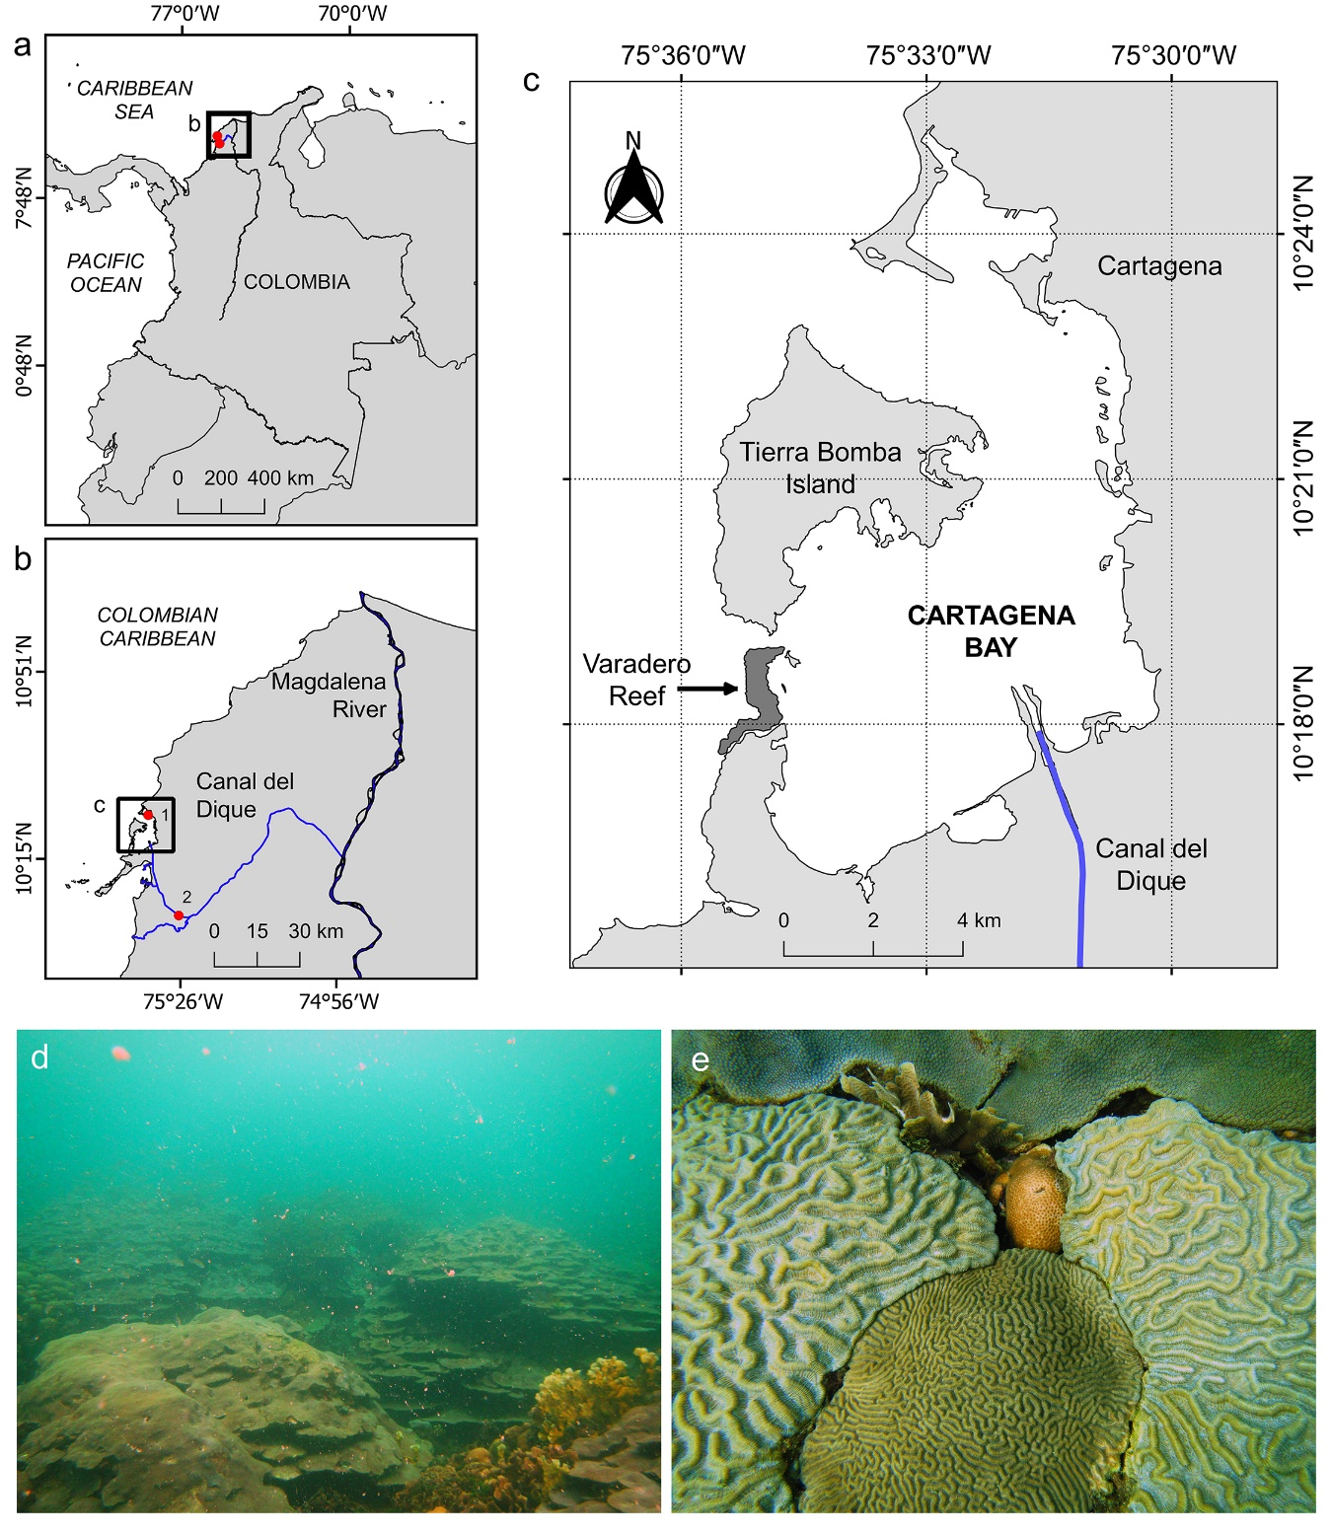
Figure 1. Varadero coral reef. Connection between the Canal del Dique and Magdalena river (a-b), and location of Varadero reef in Cartagena Bay (c). Orbicella faveolata colonies growing like plates at 4 m depth. Notice the marine snow (d). Competition for substrate by the corals Colpophyllia natans, Pseudodiploria clivosa, Agaricia tenuifolia, Siderastrea siderea and O. faveolata (e). Hidrological and metereological stations indicated in panel b as red dots are: 1. Naval station and 2. Santa Helena 2 station.

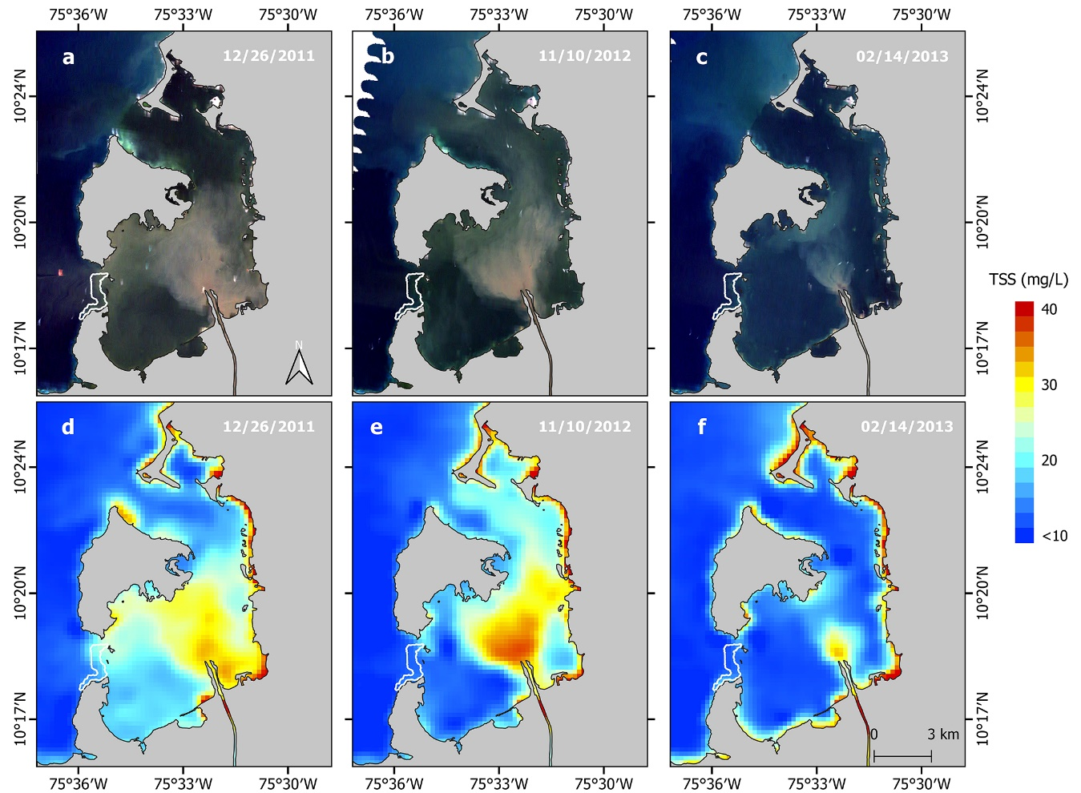

Figure 2. Total suspended sediments (TSS) within Cartagena Bay according to three different water flow rates from the Canal del Dique: high on December 26, 2011 (632 m³ s⁻¹), moderate on November 10, 2012 (378 m³ s⁻¹) and low on February 14, 2013 (158 m³ s⁻¹). Landsat 7 satellite imagery showing different levels of suspended sediments from the Canal del Dique (a-c). MODIS Terra (MOD09GQ; band 1) satellite imagery calibrated for TSS, following the model produced by Restrepo et al. (2016) for the same area (d-f). The Varadero coral reef is shown as a white-bordered polygon.

Figure 3. Climatology of hydrological and environmental data obtained for the Canal del Dique and Cartagena Bay area. Data sources and base periods are described in the methods section.

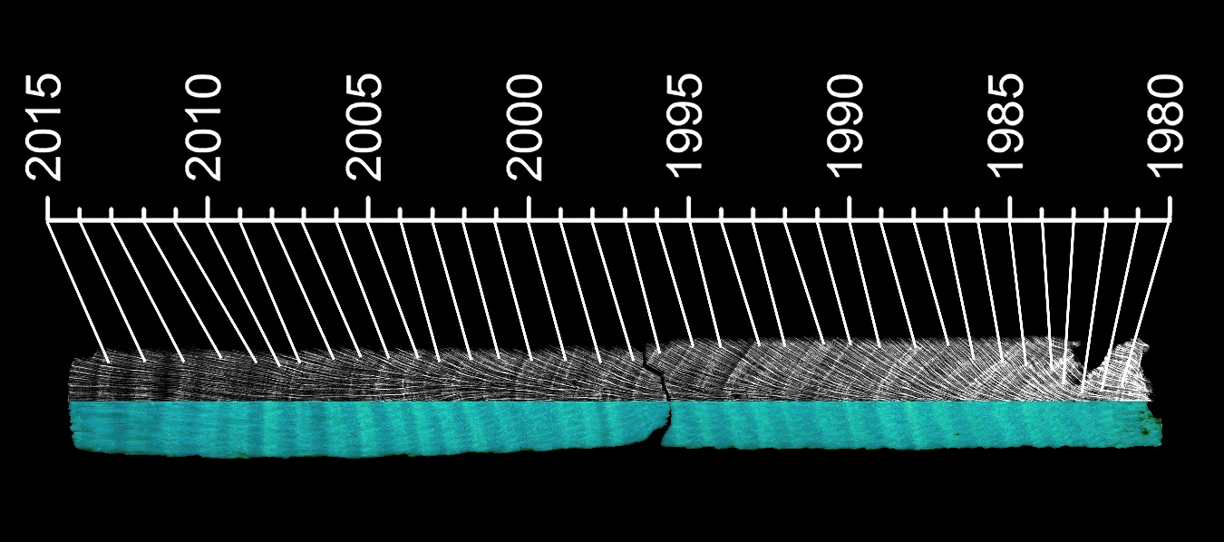
Figure 4. Banding patterns within a core (VAR1) of the coral O. faveolata. Annual skeletal density is shown as a light (low density) and dark (high density) band in gray scale (X-radiograph). Annual luminescent bands are shown as light and dark bands under UV-A light. As lighter (more intense) the luminescence band, the higher terrestrial influences recorded in the coral skeleton (Grove et al. 2010).

Figure 5. STDA coral growth time series of the corals O. faveolata collected in Varadero Reef. Black dashed line indicates a significative trend over the respective period for density (r = -0.47, p < 0.001) and calcification (r = -0.42, p < 0.001), but not for extension (r = 0.16, p = 0.194).

Figure 6. Monthly time series of coral luminescence (G/B) and hydrological data from the Canal del Dique (in STDA units), and SOI values. The positive (blue) and negative (red) SOI values are associated with La Niña and El Niño events, respectively. The yellow-shaded zone represents El Niño 97-98.

